**Computer Organization and Architechure**

**Name: Raha Habib  
Admission No:COM/0501/21**

1. The instruction: Add X, R0 is received by the CPU for processing:

(a) How will the control unit decode the instruction

**(a) Decoding the Instruction:**

The instruction "Add X, R0" is an assembly language instruction that represents adding the contents of memory location X to the contents of register R0. The control unit needs to decode this instruction to understand and execute it. The decoding process typically involves breaking down the instruction into its components:

* **Operation Code (OpCode):** Identifies the operation to be performed, in this case, addition.
* **Source Operand (X):** Specifies the source operand, which is the memory location X.
* **Destination Operand (R0):** Specifies the destination operand, which is register R0.

The control unit extracts these components during the decoding process and prepares to execute the instruction.

* **Operation Code (OpCode):** Identifies the operation to be performed, in this case, addition.
* **Source Operand (X):** Specifies the source operand, which is the memory location X.
* **Destination Operand (R0):** Specifies the destination operand, which is register R0.

The control unit extracts these components during the decoding process and prepares to execute the instruction

(b) Describe the steps in which this instruction will be executed using one bus data path   
**(b) Execution Steps Using a One-Bus Data Path:**Assuming a one-bus data path, where a single bus is used for data movement within the CPU, the execution steps for the "Add X, R0" instruction can be outlined as follows:

1. **Fetch Phase:**
   * The control unit fetches the instruction from memory and places it in the instruction register.
   * The OpCode is decoded to identify that the operation is an addition.
   * The memory address or value (X) is fetched and placed on the bus.
2. **Decode Phase:**
   * The control unit decodes the instruction further to identify the source operand (X) and the destination operand (R0).
3. **Execution Phase:**
   * The ALU (Arithmetic Logic Unit) is activated for addition.
   * The contents of register R0 are placed on the bus and combined with the value from memory location X.
   * The result of the addition is computed by the ALU.
4. **Write Back Phase:**
   * The result of the addition is written back to register R0.
   * The CPU updates its internal state to reflect the changes made during the execution of the instruction.  
     (c) Data movement within the CPU can be performed in several different ways.   
     Contrast the following methods in terms of their advantages and disadvantages:   
     i. Dedicated connections

* **Advantages:**
  + *Dedicated Paths:* Each component (e.g., registers, ALU) has a dedicated connection to transfer data, avoiding contention.
  + *Deterministic Timing:* Since each component has its own path, timing can be more predictable and easier to manage.
* **Disadvantages:**
  + *Complexity:* Requires a complex network of dedicated connections, which can increase the complexity of the CPU design.
  + *Resource Utilization:* May result in underutilization of connections during certain operations.

ii. One-bus data path

* **Advantages:**
  + *Simplicity:* Utilizes a single bus for data movement, making the design simpler and more straightforward.
  + *Cost-Effective:* Requires fewer resources, making it more cost-effective in terms of design and implementation.
* **Disadvantages:**
  + *Contended Bus:* The single bus can become a bottleneck, especially when multiple components need to transfer data simultaneously.
  + *Limited Bandwidth:* Limited by the bandwidth of the single bus, potentially leading to slower data movement.

iii. Two-bus data path

* **Advantages:**
  + *Reduced Contention:* Two separate buses (e.g., one for data and one for addresses) can reduce contention compared to a single-bus architecture.
  + *Improved Bandwidth:* Enables simultaneous data transfers, improving overall bandwidth.
* **Disadvantages:**
  + *Complexity:* More complex than a one-bus architecture, requiring additional control logic.
  + *Potential Bottlenecks:* While better than a one-bus architecture, it can still face bottlenecks during heavy data movement.

iv. Three-bus data path

* **Advantages:**
  + *Further Reduced Contention:* With three buses (e.g., one for data, one for addresses, and one for control signals), contention is further reduced.
  + *Increased Parallelism:* Supports increased parallelism in data movement operations.
* **Disadvantages:**
  + *Increased Complexity:* The additional bus increases design complexity, making it more challenging to implement and manage.
  + *Cost:* The added hardware and complexity can result in higher manufacturing costs.

2. A computer A with a 2 GHz clock speed executes a program in 8 seconds. What would be the clock rate of computer B if it must execute the same instruction in 4 seconds?

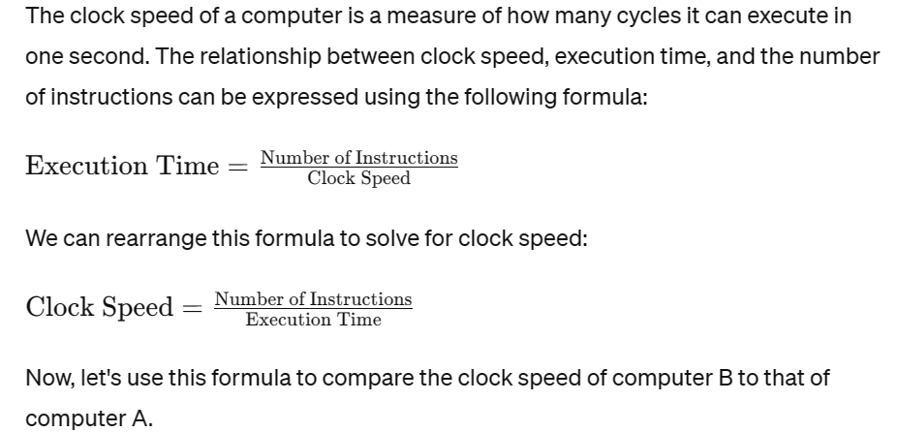

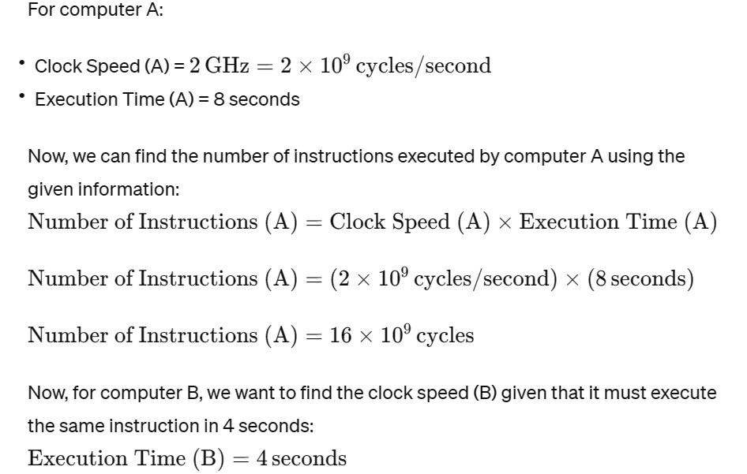

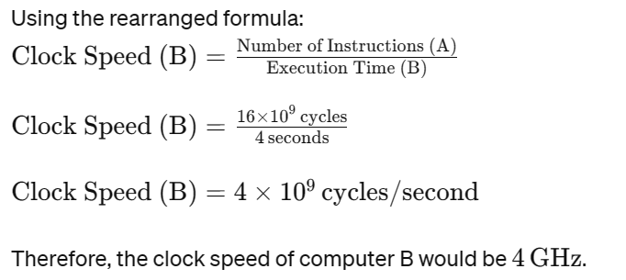

3. As a computer architect, discuss the cpu performance improvement measures

As a computer architect, improving CPU performance involves various strategies and techniques. Here are some key measures that can be taken to enhance CPU performance:

a. Clock Speed Increase:

- Increasing the clock speed of a CPU allows it to execute instructions at a faster rate. However, this can lead to higher power consumption and heat generation, so it needs to be balanced with other considerations.

b. Pipeline Optimization:

- Pipelining breaks down the instruction execution into stages, and multiple instructions can be processed simultaneously in different stages. Optimizing the pipeline design can improve instruction throughput and overall performance.

c. Instruction Level Parallelism (ILP):

- ILP involves executing multiple instructions in parallel within a single processor. Techniques like superscalar and VLIW (Very Long Instruction Word) architectures exploit ILP by executing multiple instructions at the same time.

d. Out-of-Order Execution:

- CPUs can be designed to execute instructions out of order to maximize the utilization of execution units. This involves reordering instructions dynamically to execute independent instructions simultaneously.

e. Caching Techniques:

- Effective use of cache memory can significantly improve CPU performance. Techniques such as larger cache sizes, multi-level caches, and smart caching algorithms (like prefetching) help reduce memory access latency.

f. Multiple Cores and Parallel Processing:

- Incorporating multiple processing cores on a single chip allows for parallel processing, where multiple tasks can be executed simultaneously. This is particularly effective for tasks that can be divided into parallel sub-tasks.

g. Improved Instruction Set Architecture (ISA):

- Enhancing the instruction set architecture can lead to more efficient code execution. Features like SIMD (Single Instruction, Multiple Data) instructions can accelerate certain types of computations.

h. Branch Prediction:

- Branch prediction techniques help the CPU predict the outcome of conditional branches in code. This helps in avoiding pipeline stalls, ensuring that the CPU is always processing instructions.

i. Hardware Acceleration:

- Offloading specific tasks to dedicated hardware accelerators or coprocessors can greatly improve performance for certain workloads. Examples include GPUs for graphics processing and specialized accelerators for machine learning tasks.

j. Power Management:

- Efficient power management techniques, such as dynamic voltage and frequency scaling (DVFS), allow the CPU to adjust its performance based on the workload. This helps in saving power when high performance is not required.

h. Memory Hierarchy Design:

- Optimizing the memory hierarchy, including main memory and caches, is crucial for improving CPU performance. Techniques like cache associativity and memory interleaving can be employed to enhance memory access speed.

i. Advanced Manufacturing Processes:

- Utilizing advanced manufacturing processes (such as smaller nanometer technologies) can lead to improvements in energy efficiency and the overall performance of CPUs.

It's important to note that these measures often involve trade-offs, and the optimal design depends on the specific requirements and constraints of the target application and system. Advances in computer architecture continually explore new techniques to push the boundaries of CPU performance.

4. What does the future of computer organization and architecture looks like?

Predicting the future of computer organization and architecture involves considering current trends, emerging technologies, and potential shifts in computing paradigms. While the exact trajectory is uncertain, several key areas are likely to shape the future of computer architecture:

a. Quantum Computing:

- Quantum computing holds the promise of solving certain problems exponentially faster than classical computers. As the field advances, we may see the integration of quantum computing elements into hybrid systems that leverage both classical and quantum processing.

b. Neuromorphic Computing:

- Inspired by the human brain, neuromorphic computing aims to build processors that mimic the structure and function of neural networks. This could lead to highly efficient and powerful processors for tasks such as artificial intelligence and machine learning.

c. Specialized Accelerators:

- The trend of incorporating specialized accelerators for specific workloads, such as graphics processing units (GPUs) for parallel tasks and application-specific integrated circuits (ASICs) for certain algorithms, is likely to continue. This trend enhances performance and energy efficiency.

d. 3D Stacking and Integration:

- 3D stacking of integrated circuits allows for the vertical integration of multiple layers of components. This can lead to denser and more energy-efficient designs, enabling faster data transfer between different parts of the system.

e. Optical Computing:

- Optical computing, which uses photons instead of electrons to perform computations, could potentially overcome the limitations of traditional electronic computing. Optical interconnects may also become more prevalent, improving data transfer speeds within and between computer systems.

f. Advanced Memory Technologies:

- Developments in memory technologies, such as resistive RAM (ReRAM), phase-change memory (PCM), and memristors, could lead to faster and more energy-efficient memory solutions, reducing the memory bottleneck in computing systems.

g. Edge Computing:

- As the Internet of Things (IoT) continues to grow, there will be an increased emphasis on edge computing. This involves processing data closer to the source of generation, reducing latency and bandwidth requirements and improving overall system responsiveness.

h. Security and Privacy Enhancements:

- Given the increasing concerns about cybersecurity, future computer architectures are likely to place a greater emphasis on built-in security features, secure enclaves, and privacy-preserving technologies.

i. Biologically-Inspired Computing:

- Drawing inspiration from biological systems, future architectures may incorporate principles of self-organization, adaptability, and fault tolerance. Bio-inspired computing could lead to more robust and resilient systems.

j. Energy-Efficient Designs:

- Continued focus on energy efficiency is expected, driven by environmental concerns and the need for sustainable computing. This includes innovations in power management, low-power design, and energy-efficient algorithms.

k. Open and Scalable Architectures:

- The development of open-source hardware and scalable architectures will likely continue, fostering collaboration and innovation. Standards like RISC-V and open hardware initiatives aim to provide a more flexible and customizable approach to computer architecture.

l. Heterogeneous Computing:

- Systems with a mix of different types of processing units (CPU, GPU, FPGA, etc.) working together are becoming more common. Future architectures may further optimize the coordination and utilization of heterogeneous resources for improved performance.

It's important to note that the future of computer architecture will be shaped by ongoing research, breakthroughs in materials science, advancements in manufacturing technologies, and the evolving demands of applications and workloads. As technology continues to advance, new opportunities and challenges will likely redefine the landscape of computer organization and architecture.